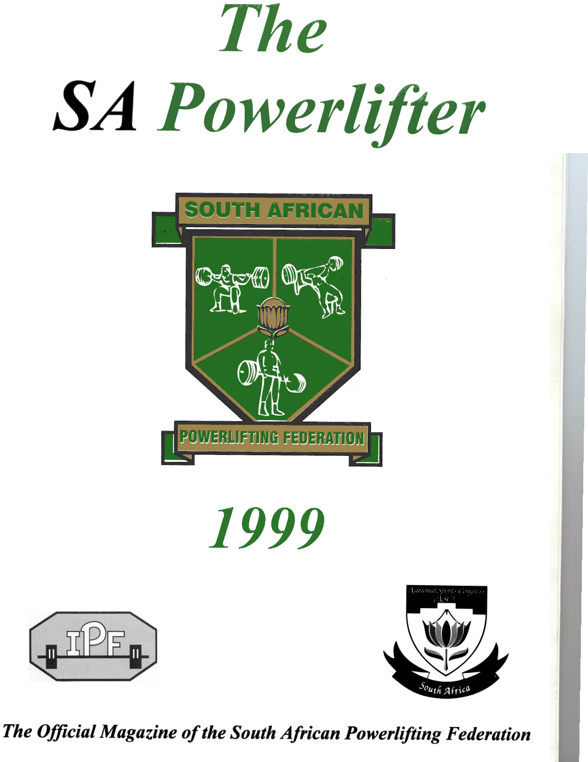

Date: 28 November 2009
Place: Oxygen Fitness and Wellness Centre, Zambesi Retail Park, Pretoria
Time: 11:00
Weigh In: 09:00 To 10:30
Contact: Helgard Coertze 078 322 7191
Entry Fee: R200-00 per lifter
T-Shirt: R60-00
Closing Date: Nomination 30 September 2009
Final entry 28 October 2009
Banquet Yes – info will be posted asap

Name | Weight Category | Male/Female | T-Shirt  Size

Province: _______________________________________

Manager: _______________________________________

Coach: _______________________________________

Referees (Available): _______________________________________

*NO INDIVIDUAL ENTRIES – ALL LIFTERS MUST BE ENTERED BY THEIR PROVINCES

*ENTRY FEES MUST BE PAID INTO:

FNB Bank; LYNNWOOD BRANCH 252045; CHEQUE Account; Acc No. 5108033931; Acc. Holder. GUATENG NORTH POWERLIFTING.

Deposit Slips and entry forms must be faxed or e-mailed before or on the closing date.

Fax 086 654 6978

e-mail helgard@oxygengym.co.za

*NO LATE ENTRIES – Lifters not on preliminary nomination list cannot be included on final entry form

*PROVINCES MUST ENSURE THAT ALL LIFTERS ARE AFFILIATED

*NO AFFILIATION OR ENTRY FEE = NO COMPETITION!!

